**Phase 7: Integration & External Access**

**Objective:**

The goal of this phase was to write an Apex class that simulates fetching data from an external system, a common requirement in banking for tasks like checking a loan application status from a core banking system.

**Completed Actions:**

* **Apex Callout Class:** An Apex class named **LoanStatusController** was created to handle the logic for making a REST callout to an external web service. This class prepares an HTTP request and processes the response.
* **Mock Service for Testing:** To test the callout functionality without relying on a live external system, a mock callout class named **MockLoanStatusService** was developed. This class implements the HttpCalloutMock interface to return a fake, successful response, allowing for predictable and reliable testing.
* 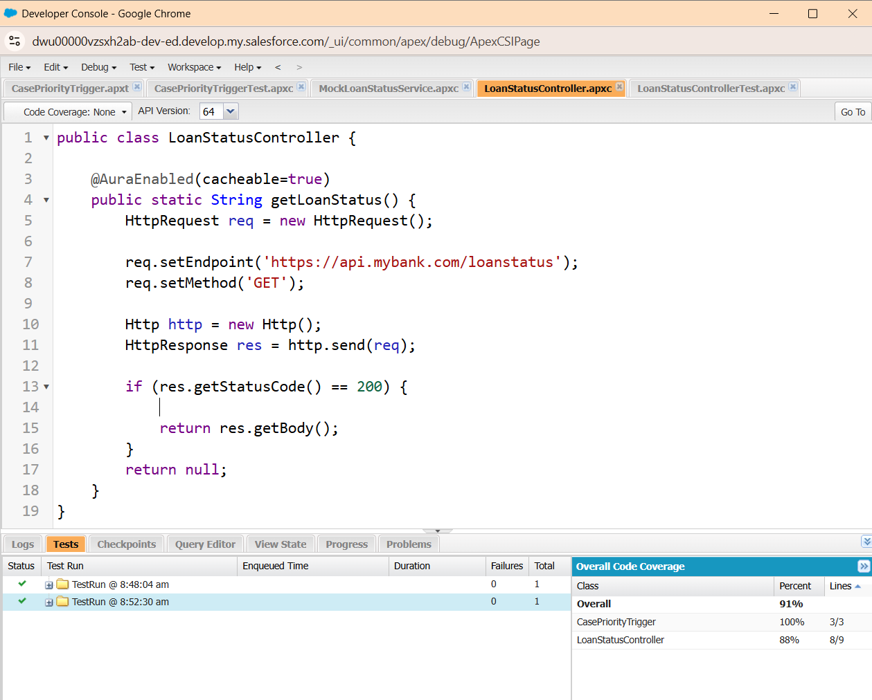**Apex Test Class:** A dedicated test class, **LoanStatusControllerTest**, was written to verify the integration logic. The test class uses Test.setMock to instruct Salesforce to use the mock service during the test. It then calls the callout method and asserts that the expected mock response was received, ensuring the integration code works correctly.

